**MS**

**PowerPoint**

**Class Five**

**Lab 18**

|  |
| --- |
| Lab Objectives:  * Introduction to PowerPoint |

# What is PowerPoint?

## PowerPoint is a slide show presentation program that's part of the Microsoft office suite of tools. PowerPoint makes it easy to create, collaborate, and present your ideas in dynamic, visually compelling ways.

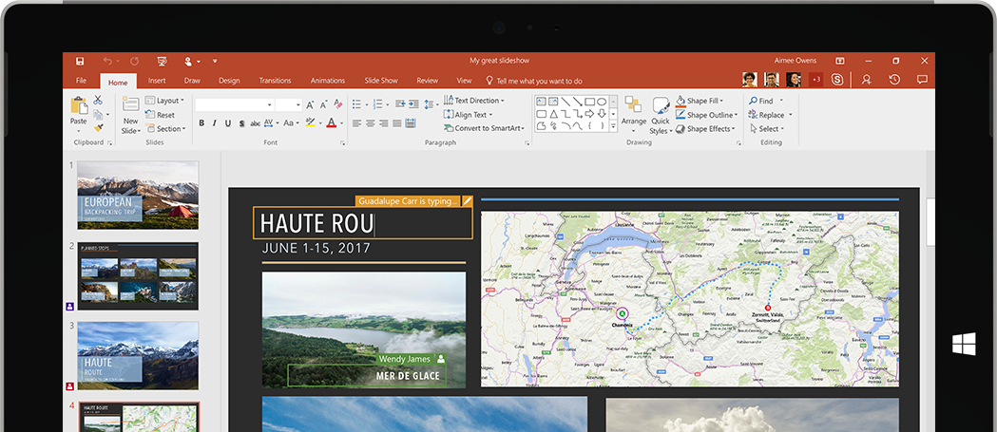

# Open PowerPoint

## Go to all programs --> click Microsoft office --> then click Ms PowerPoint.

## (Picture below is responsible for opening ms word)

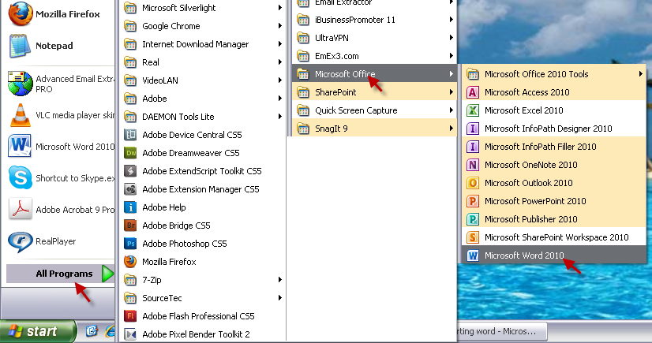

# PowerPoint Template

## There are many versions of PowerPoint. We are using PowerPoint 2010 in this lab. You can use any of your preferred one.

## One way of creating a presentation is to start from scratch. However, you can save time and effort if you base your new presentation on a template.

## A template defines the background, font styles, colour and sizes for your placeholders, as well as selected bullets that match the template. Using a template means that you don't need to worry about defining those aspects yourself.

## To create a PowerPoint presentation using a template, click the File tab > New, and the following panel will be displayed.

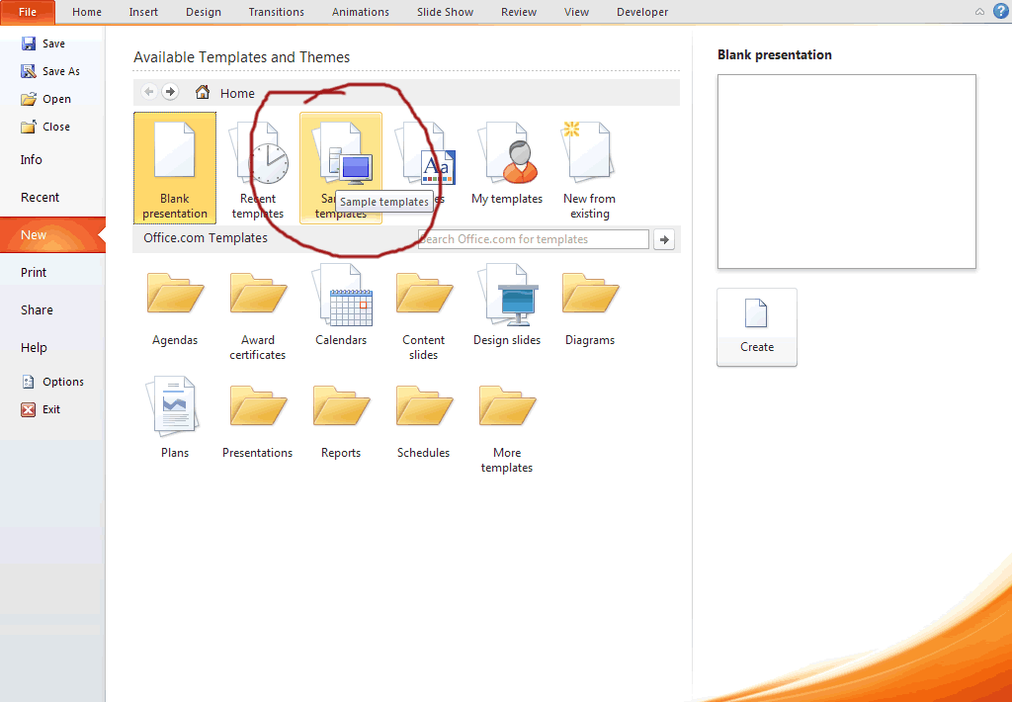

## Clicking on a template category will display thumbnail images of all the templates within that category. When you find a template you like the look of, click on its thumbnail to select it and you will see a preview of it on the right of the panel.

## You can then click Create to create your PowerPoint presentation based on this template.

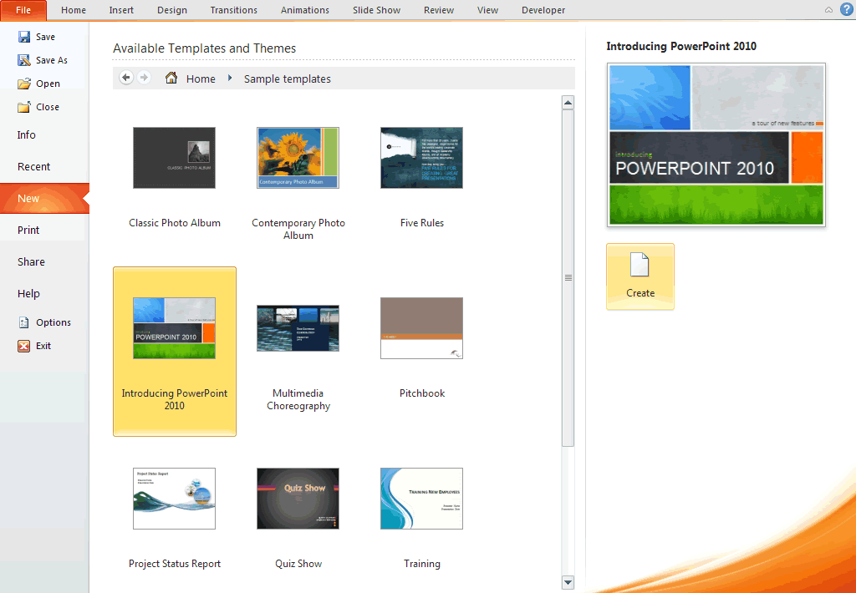

## Sometimes you just can't find a template that precisely matches what you need, and in these circumstances, what many people do is use a template that is the closest fit and then modify it.

# Open an Existing PPT File

## There are several reasons why you might need to open an existing Microsoft PowerPoint presentation instead of creating a new one. You might have previously saved an incomplete presentation and now need to do some more work on it. Alternatively, you might want to open a complete presentation and actually run it for an audience. Whatever the reason, opening an existing presentation is quite easy.

## Start PowerPoint and then click the File tab > Open. The usual Open file dialogue box that you may already be familiar with opens and you use this to locate your presentation.

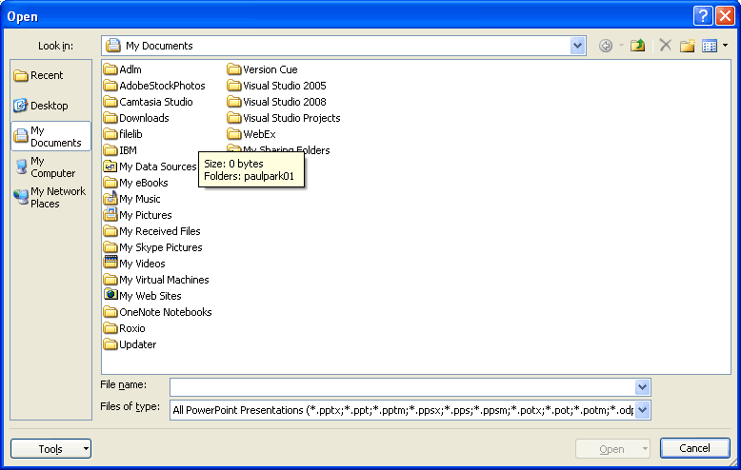

## When you find your presentation, either double click it to open it, or select it and then click Open. The presentation will then open for you to either work on it or run it.

## The keyboard shortcut for opening a presentation the same as that for opening existing documents in other Microsoft Office programs: **Ctrl-0**

# Adding New Slides

## There are a couple of ways to add a new slide. In each way, the slide that is currently selected is important as the new slide will be placed after the selected one.

## Once you have selected a slide, click Home > Slides > New Slide. You'll notice that the New Slide button is in two halves.

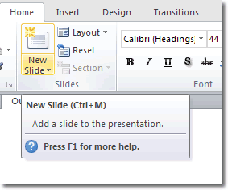

## If you click the top half of the New Slide button, the default Title and Content type slide will be added. If, instead, you click the bottom half of the button, you will be able to select what type of slide is added.

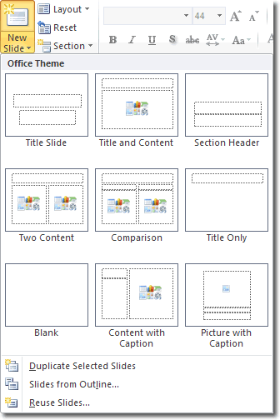

## Once the new slide has been added, you can click into one of the editable content boxes to make your changes.

## The keyboard shortcut for adding new slides is Ctrl-m.